**Report 3: Results Findings**

**Results** The Decision Tree Classifier reached a prediction accuracy level of 87.5%. The unsupervised model, K-Means Clustering, had mediocre performance in clustering, with an Adjusted Rand Index of 0.438. The MLP Neural Network was able to reach up to an accuracy of 87.5%, while the CNN was also at 87.5%.

**Analysis**

**Decision Tree Classifier**

* The model performed well, with the majority class being decently classified and some of the minority classes posing a problem, which was evident from the confusion matrix.

**K-Means Clustering**

* This model is ineffective for direct classification, for it acts in an unsupervised manner. Consequently, the performance was moderate.

**MLP Neural Network**

* The model performance was very good, as it was able to capture a lot of complex data patterns. There was an overfitting problem. This is clear from the training and validation loss curves.

**CNN**

* Usually, the CNN is used on image data, but it performed well on classification work. It showed lesser performance compared to MLP, which is due to the dataset characteristics.

**Conclusion** This comparative analysis provided results showing that classical machine learning models like the Decision Tree Classifier will work in league with deep learning models like MLP and CNN for small or imbalanced datasets.The results pinpoint that model selection and preprocessing strategies play a vital role in handling the class imbalance. Further work can be done in the terms of hyperparameter tuning, and the data could be increased to improve the model.

**Appendix**

**Class Distribution before and after the removal of Class G**

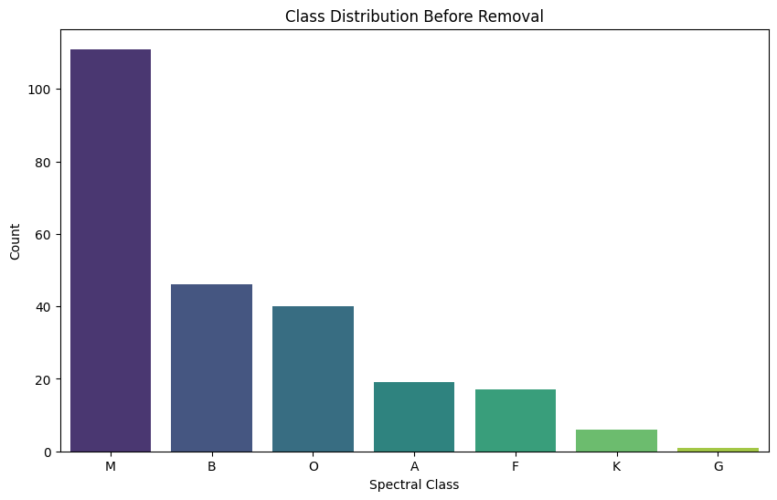 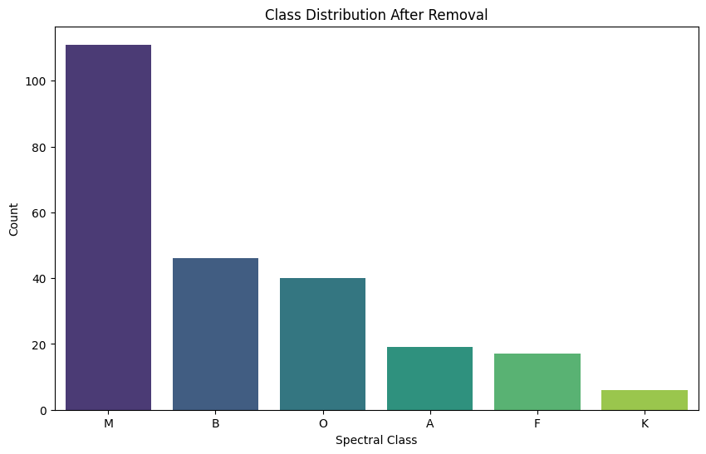

**Confusion Matrix:**

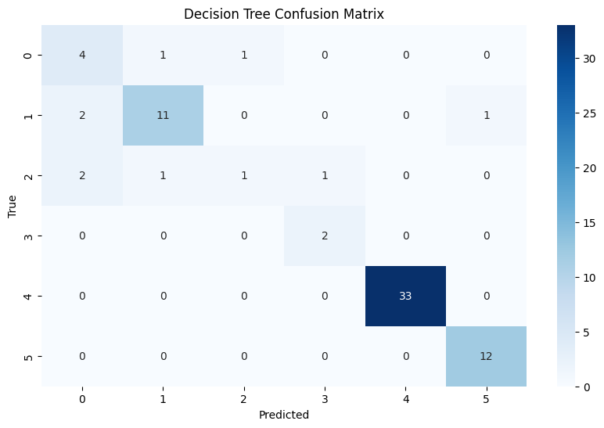

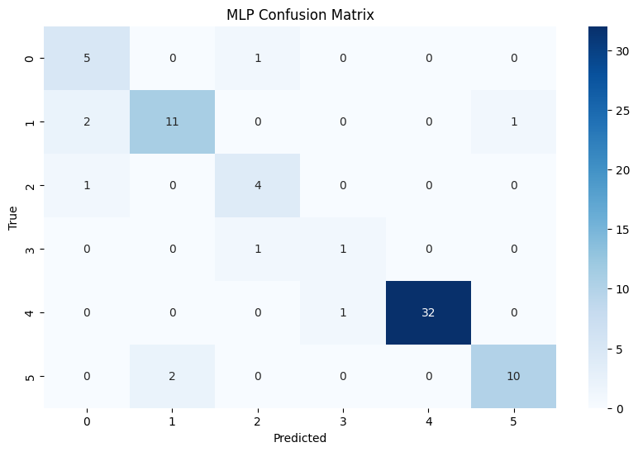

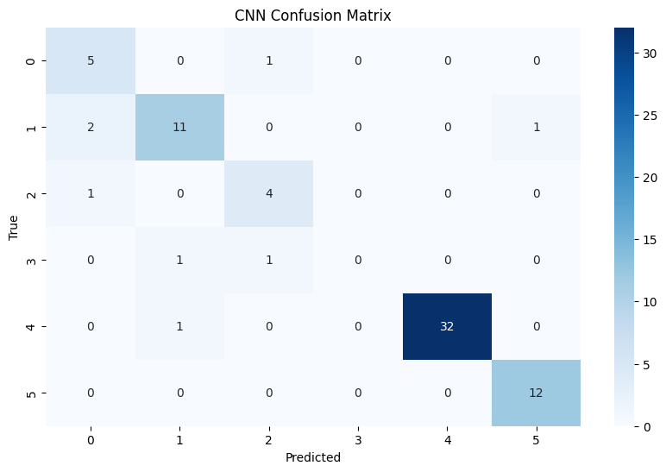

**Comparison Results:**

